Car Resale Price prediction

# Welcome



index.

h

tm

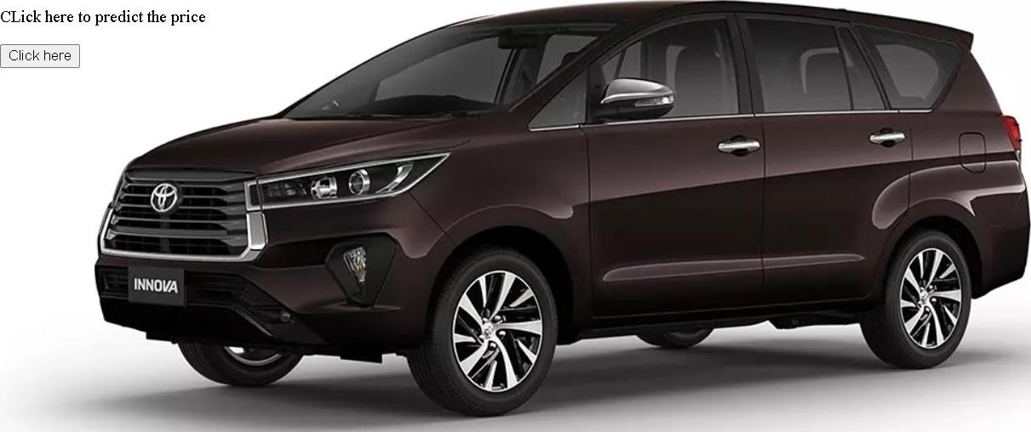

280CENG20:10

CloudyIN05-11-2022

# HTML Forms

Please fill the details or your car:

|  |
| --- |
| 2010 |

Reg Ye

|  |
| --- |
| 4 |

Reg Month:

|  |
| --- |
| 5 |

Power ofCar in PS:

|  |
| --- |
| 27000 |

Kilometer the car has to driven:

Expected Budget:

Gear Box Type : Manual: Not-declared:



Automatic:

Your car is damaged or Repaired: Yes: No: Not-declared: o

|  |
| --- |
| i 10 era |

Model Type:

|  |
| --- |
| Hyundai |

Brand ofthe car:

Fuel Type : cng: Petrol: Diesel: o

|  |
| --- |
| Car |

Vehicle Type:

predict

The resale value predicted is 3345678.00$

280CENG20.11 CloudyIN05-11-2022